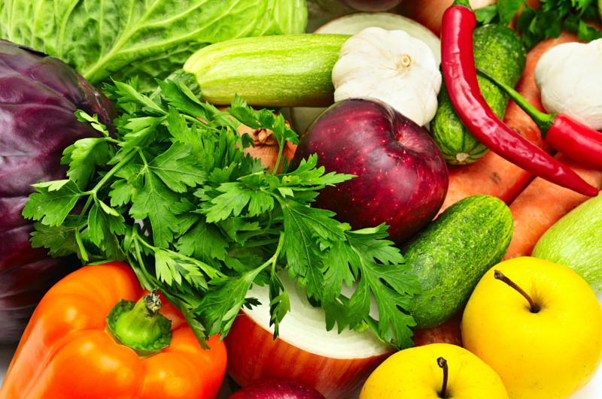

**Enroll in Weekend Food for Kids!**

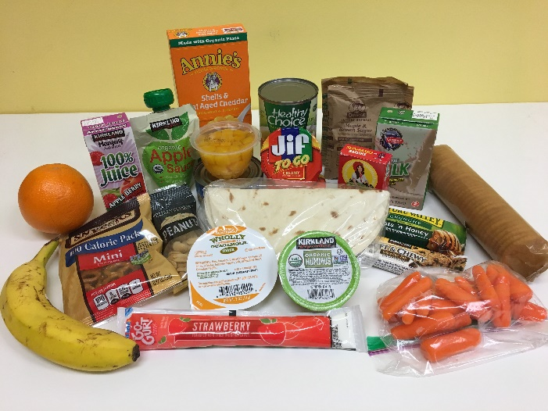

**Weekend Food For Kids**

* Free weekend packs include 3 dinners,

2 breakfasts, 2 lunches, and snacks.

* Open to ALL students at Cascadia.
* No income eligibility requirements.
* Can accommodate dietary restrictions: vegetarian, halal, allergies, etc!

**For more information, contact: Tammy Foulk, Counselor**

**206-413-2013, tafoulk@seattleschools.org**

To sign up: Call, email, or return the bottom portion of this flyer to the office.

WEEKEND FOOD FOR KIDS

Student Name ___________________________________________________________

Grade ___________________ Teacher _______________________________________

Allergies/Dietary Restrictions _______________________________________________