Accessing Seattle Public Schools eBooks
This experience works best if you log in with your SPS Username/Password, but the generic account (Username: studentsps / Password: access) will work for most functions.

- Go to https://www.destinydiscover.com
- Select Location: Washington / School: Your School and click GO
- Select Login

- Scroll down to the eBook section
- Click the book you want

Reading Options:
  - If you want to read the book online in your web browser (Chrome/Firefox, Edge), simply select Open
    - When you are finished using the book, be sure to select “Close Book” so that it will be available for another person
Note – there is no Kindle app at this time, so simply read online on your Kindle

b. If you would like to access the book on a mobile device, such as an iPhone or Android, select Checkout and then download the “Destiny Read” app from iTunes or Google Play. You can only Checkout a book if you login with an individual account: it is not available with the generic studentsps/access account
    - Within the app, select Location: Washington / School: Your School
    - Select Login and enter your SPS Username and Password
- The titles you have checked out, will automatically appear within the app
- Select Open

To navigate within the book tap at the top of the screen | Select Close Book to switch books
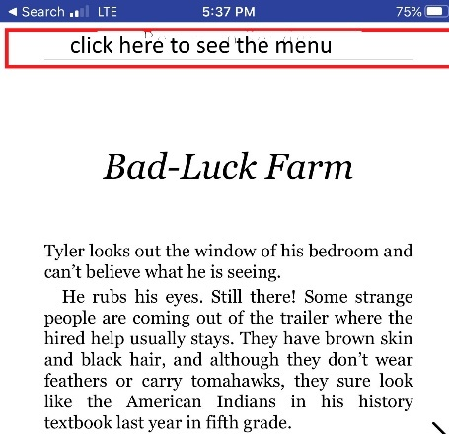 | 