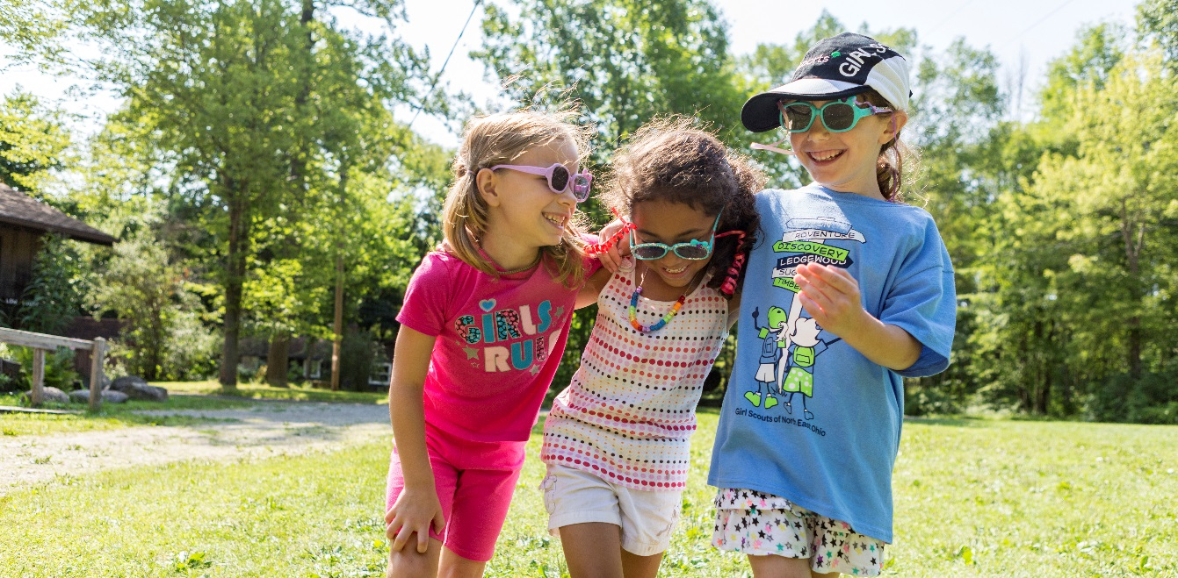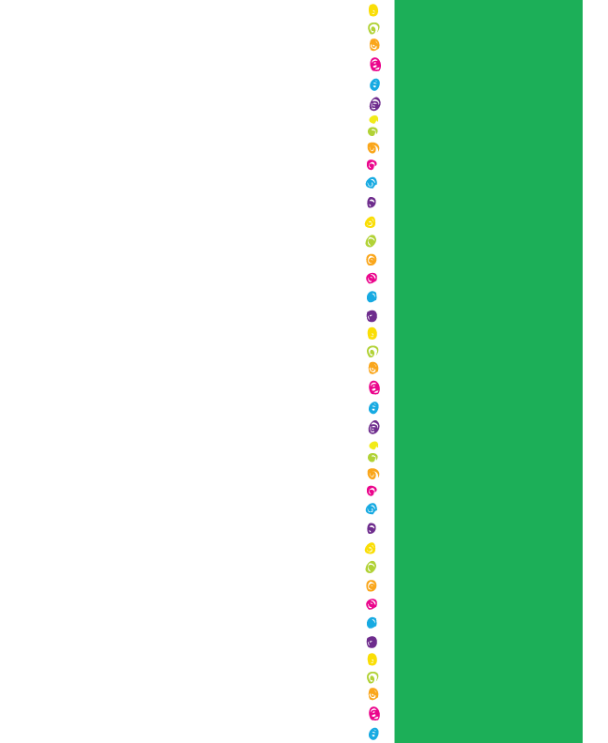­

Join Girl Scouts

in Your Community!

Brownie Troop 46139

(2nd/3rd grade)

*Still needs two volunteers!*

Daisy Troop 47051

(K/1st grade)

*Still needs two volunteers!*

Junior Troop 45294

(4th/5th grade)

*Still needs two volunteers!*

Don’t see a troop that works for you? Check out our online catalog for grades K-12.

Troops Accepting New Girls:

Contact Maddie Small for more information: msmall@girlscoutsww.org

Come and find out more about becoming a Girl Scout! Share the news and bring a friend! Be a part of supporting girls in your community!

**Monday, December 16th 6:30pm-7:30pm**

**Cascadia Elementary Library**

1700 N 90th St, Seattle, WA 98103

**To join now go online to** [**www.GirlScoutsww.org**](http://www.GirlScoutsww.org)

Click “Join” and choose a troop by grade level.

Financial Aid is available if you qualify!