Spring in the Cascadia School Garden
by Rowan Maya Green
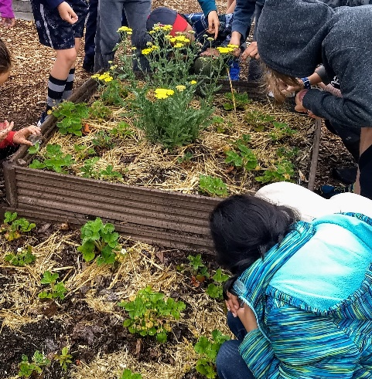
It's been a great year in the school garden, where third graders have cheerfully dug, weeded, assembled and moved beds, planted, and more. It is also my last year at Cascadia Elementary. After four and a half years, I am moving on, but the school garden program will live on! More on that in a bit...
Over the past two Fridays, we wrapped up a year of planting, harvesting, tending, and learning. We ended, as always, with sharing a school-grown garden feast, stories and songs.

On the menu at Cascadia Cafe:
Scarlet runner bean hummus with snow pea and snap pea dippers
Heirloom lettuces and edible viola blossoms
Awesomesauce salad vinaigrette, made by students
Mint tea with herbal sugars
Cucumber lime water

Ask your student about the recipe cards we sent home for Awesomesauce Vinaigrette and Scarlet Runner Bean Hummus! Early in the season the students were given a scarlet runner bean to take home. You can still plant it for a small harvest of dry beans and make your own scarlet runner hummus. It turns out a rich, earthy purple due to the purple beans. Hummus and vinaigrette are easy and fun to make with kids, and the homemade versions are tastier and cost less than store-bought.

We always focus on growing organic heirloom vegetables; they are so unique and have great flavors that you just don't find in the supermarket. Farmer's markets are great places to pick up heirloom veggies over the summer, and dry beans and winter squash in the fall!

We began our Spring session with a lesson on seed saving, and we explored some of my favorite seed catalogs: High Mowing Seeds, Baker Creek Heirloom Seeds, and Territorial Seed Company. We learned how farmers plan crops based on the descriptions of plants in seed catalogs: Short or long growing, for flavor, for size, or even just for uniqueness.

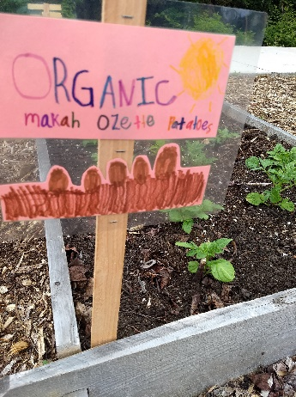
In Session 2, we learned about the history of the Makah Ozette Potato, which has been grown by the Makah people of Neah Bay for over 200 years. It is in the Slow Food Ark of Taste for a good reason: It is hearty, has a creamy texture, and is high in protein. We have been growing this potato in the Cascadia Garden for four years, thanks to a donation of potatoes by Slow Food Seattle.

In Session 3, we learned about how a plant grows from a tiny seed. Each student planted seeds into trays that we grew under lights in the third grade pods. When they were big enough, we planted our starts in the school garden. We had so many tomatoes this year that we gave many away. Enjoy your heirloom tomatoes!

Session 4 was all about flowers! We learned about flower anatomy and pollination, looking inside real flowers on the overhead projector and naming the parts. Outside in the garden, we got to see live wild pollinators hard at work, collecting nectar and spreading pollen in all of our flowering plants.

Session 5 was our Seed Dispersal lesson. We learned about how pollination creates seeds for flowering plants, and how the plants let their seeds spread around the ecosystem and the world! The students each made a Three Sisters seed ball. We talked about how the First Peoples of the plains plant the "Three Sisters" - corn, beans, and squash - and how they grow together symbiotically. Our seed balls also contain flowers for attracting pollinators.

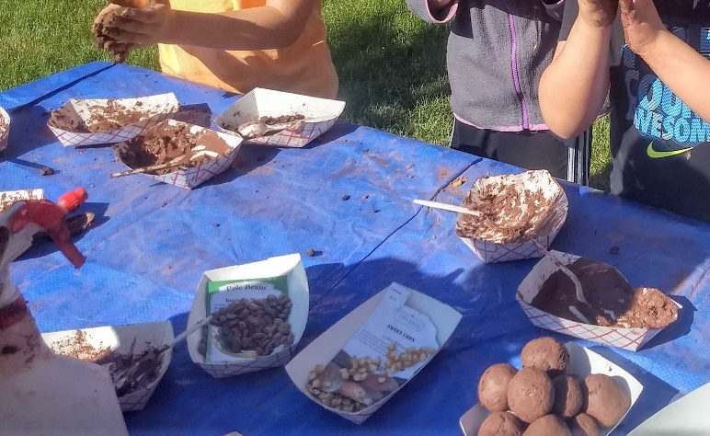

In Session 6, we focused on plant anatomy, especially on parts of plants that we eat! Did you know that we are eating the immature flower buds of broccoli and cauliflower? There was plenty of weeding and digging to do in the school garden that week, too!

Session 7 is a favorite among garden class students. We learned about beneficial insects like ladybugs and how gardeners can partner with them to control pests like aphids in their gardens. Our lesson about insect anatomy and singing “The Insect Song” was a great refresher for students. Then, we went out to the garden to meet live ladybugs and snails, and to examine deceased bees and wasps. Afterward, we released the ladybugs into the school garden to get to work on eating our aphids.

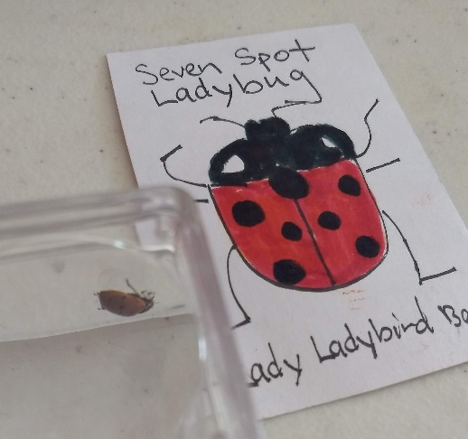
The garden is abundant with beans, lettuce, potatoes, peas, cherry tomatoes, corn, strawberries, zucchini, sugar pumpkin, herbs, and more. Our stellar Garden Coordinator Sherry Lueders has a shed on its way over the summer. Next year the garden tools and supplies can be stored more efficiently and securely. Our amazing garden volunteers have formed an unbelievable team to help set up and take down lessons, present Garden Recess and extra garden lessons and activities, and plan and prepare our garden feast. We always need more help with watering, maintenance, grant-writing, and planning! Please message gardencoordinator@cascadiapta.org if you are interested in volunteering.
I have moved from Seattle, my home of 18 years, to the much smaller city of Olympia, where I am studying Sustainable Agriculture and Education at The Evergreen State College. It is time for me to say, "So long, and happy trails" to the incredible faculty, staff, teachers, parents and of course the STUDENTS at Cascadia Elementary School. It has been an honor and a privilege to teach garden classes to the 3rd grade students at APP @ Lincoln and Cascadia Elementary. Over 700 students got to experience the benefits of experiential garden education, thanks to the dedication of the PTA, who envisioned, created and supported the garden program. And I am thrilled to confirm that the Cascadia Garden program will continue next year with a new Garden Educator and an expanded program that will reach even more students.

Keep growing!

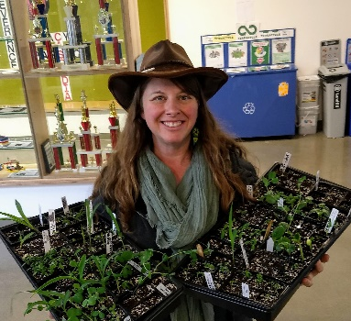
In gratitude,

Rowan Maya Green - "Ms. Rowan"
School Garden Educator

